User Database

<<Component>>

User Profile page

Events Database

<<Component>>

Events Page

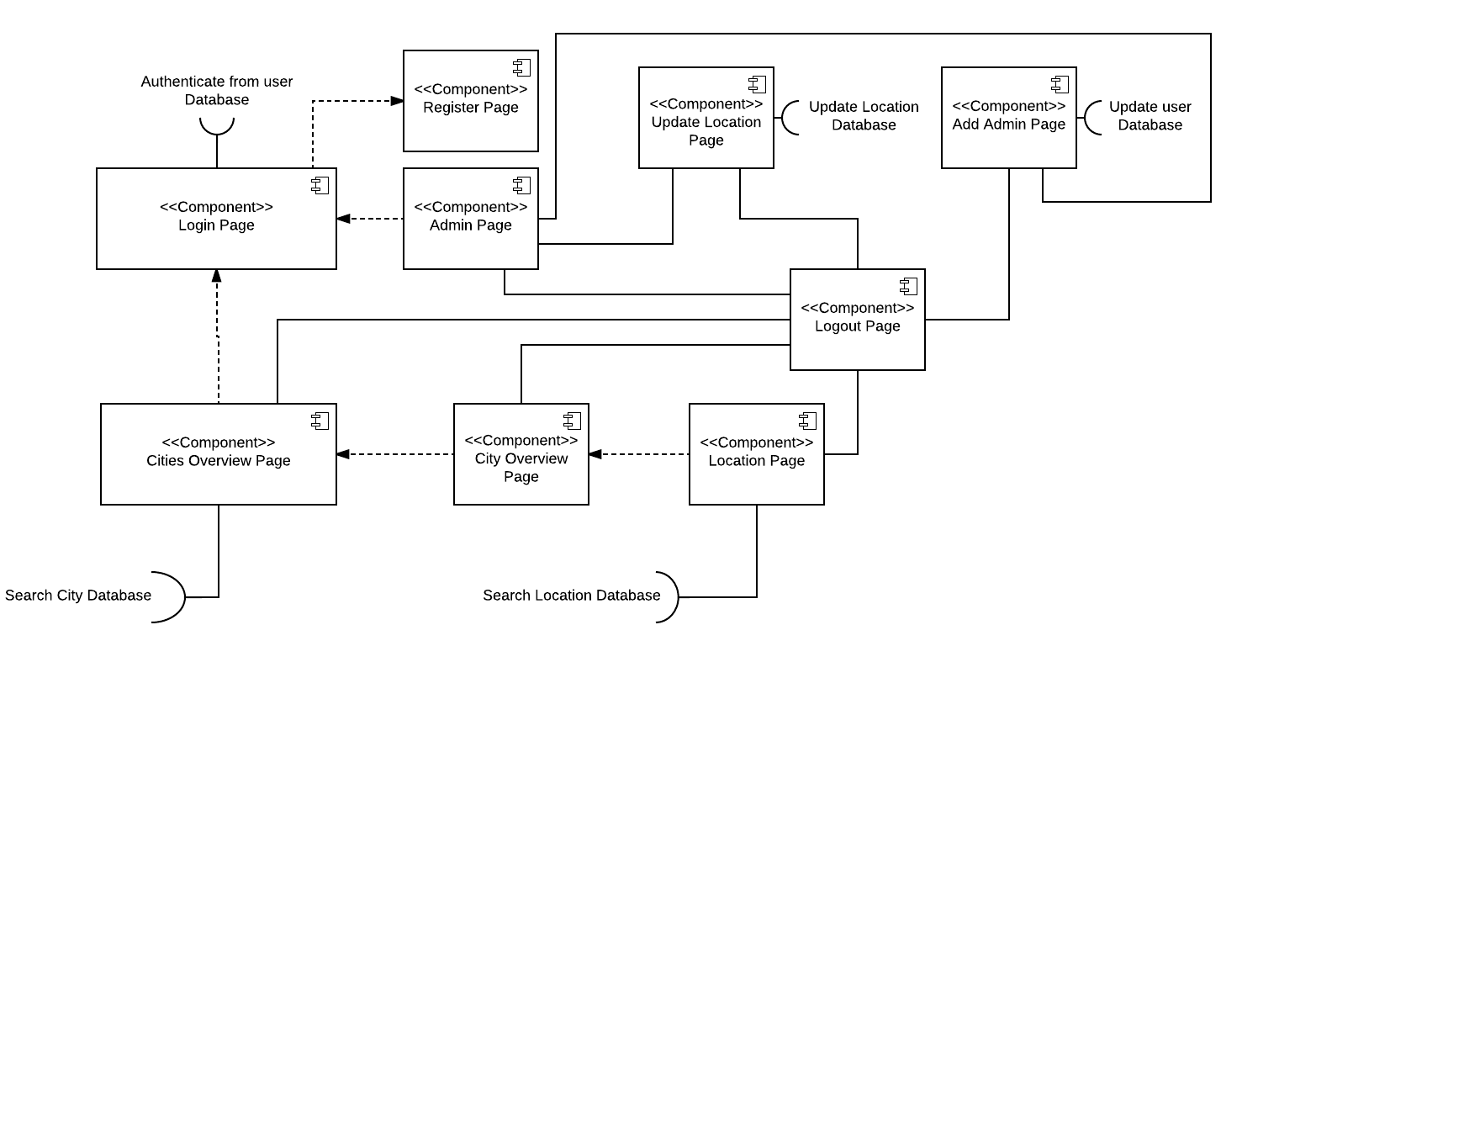

Australia Map Database

<<Component>>

Australia Map page

Location Review Comments Database

Location Review Database

University Department Database

<<Component>>

University Department page

<<Component>>

Location Review Comments

<<Component>>

Location Review page

<<Component>>

Location Comparison page